WEB PROGRAMMING LANGUAGE THEORY
CCP
INSTRUCTOR: SIR FARAZ ABDUL BASIT

MUHAMMAD Nail Ashraf
IU04-0322-0060

Screenshots:
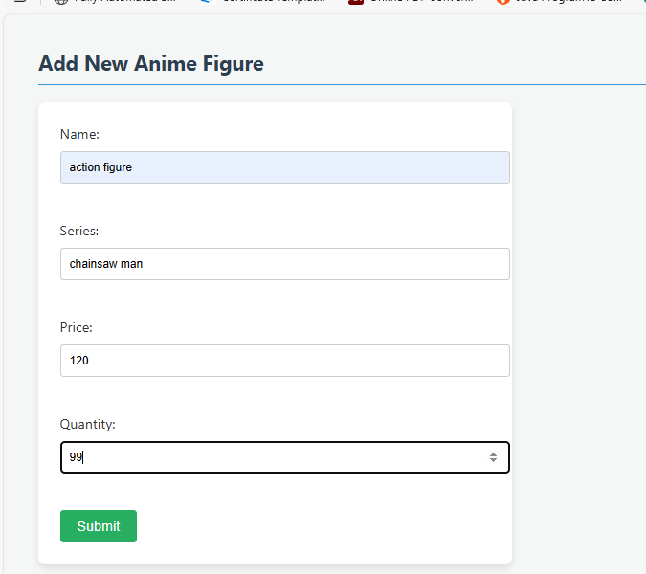

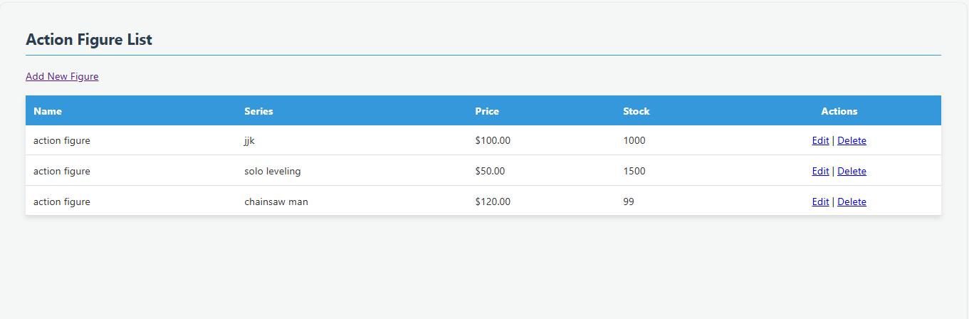

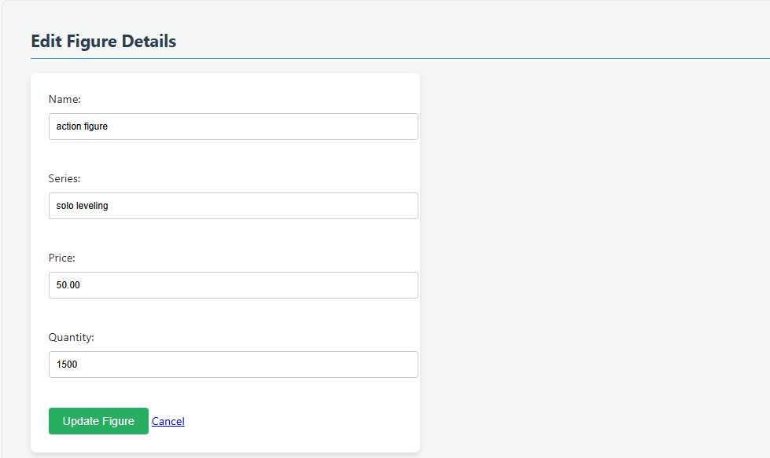

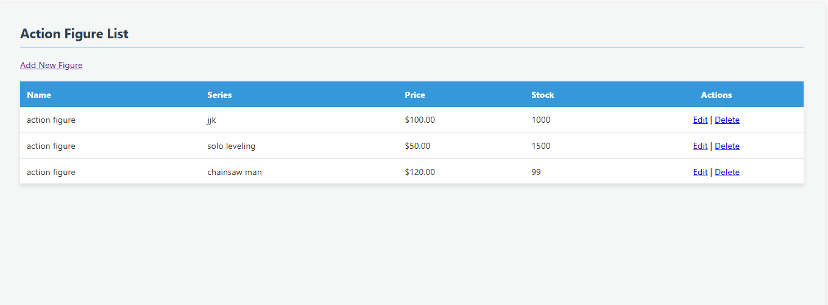

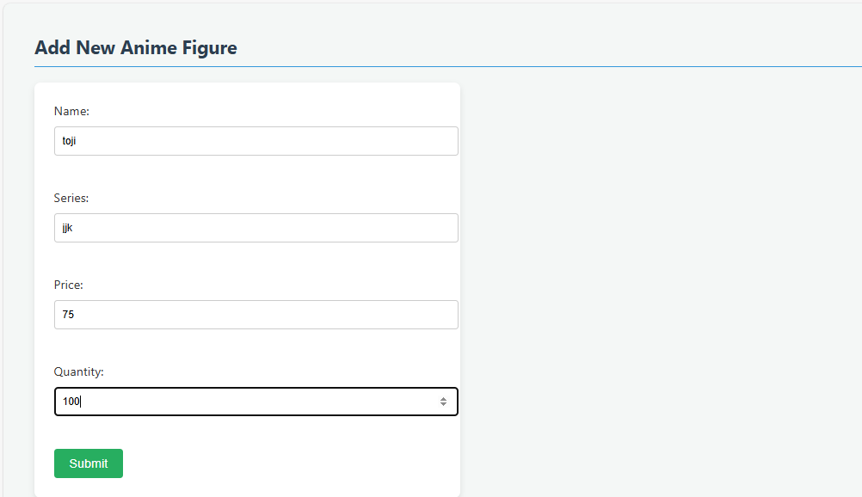

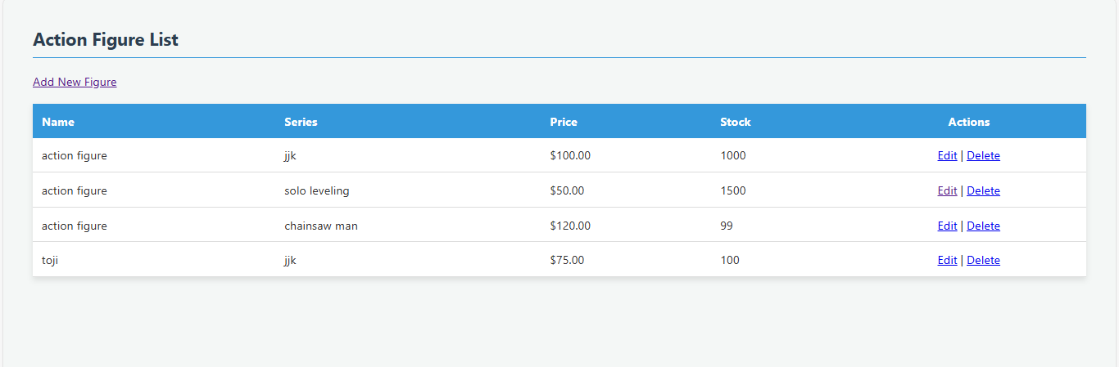

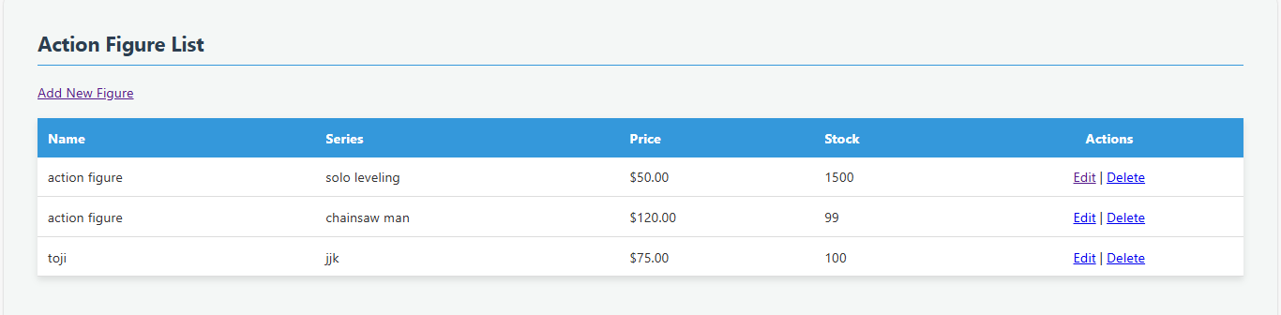

CODE:
Index.php
<?php
include 'db_connect.php';

// Check database connection
if ($conn->connect_error) {
die("Connection failed: Please try again later.");
}
?>

<!DOCTYPE html>
<html lang="en">
<head>
<meta charset="UTF-8">
<meta name="viewport" content="width=device-width, initial-scale=1.0">
<title>Action Figure List</title>
<link rel="stylesheet" href="style.css">
</head>
<body>

<div class="container">
<h2>Action Figure List</h2>

<a href="add_figure.php" class="btn btn-add">Add New Figure</a>

<table>
<thead>
<tr>
<th>Name</th>
<th>Series</th>
<th>Price</th>
<th>Stock</th>
<th style="text-align: center;">Actions</th>
</tr>
</thead>
<tbody>
<?php
// Secure SELECT query using prepared statements
$query = "SELECT id, figure_name, anime_series, price, stock_quantity FROM action_figures";

if ($stmt = $conn->prepare($query)) {
$stmt->execute();
$result = $stmt->get_result();

if ($result->num_rows > 0) {
while ($row = $result->fetch_assoc()): ?>
<tr>
<td><?= htmlspecialchars($row['figure_name']) ?></td>
<td><?= htmlspecialchars($row['anime_series']) ?></td>
<td>$<?= number_format($row['price'], 2) ?></td>
<td><?= (int)$row['stock_quantity'] ?></td>
<td style="text-align: center;">
<a href="edit_figure.php?id=<?= $row['id'] ?>" class="btn-edit">Edit</a> |
<a href="delete_figure.php?id=<?= $row['id'] ?>" class="btn-delete" onclick="return confirm('Delete this figure?')">Delete</a>
</td>
</tr>
<?php endwhile;
} else {
echo "<tr><td colspan='5' style='text-align:center;'>No anime figures found.</td></tr>";
}
$stmt->close();
} else {
echo "<tr><td colspan='5' style='text-align:center;'>An error occurred. Please contact the administrator.</td></tr>";
}
?>
</tbody>
</table>
</div>

</body>
</html>

Style.css
/* Global styles for the Anime Store */
body {
font-family: 'Segoe UI', Tahoma, Geneva, Verdana, sans-serif;
background-color: #f4f7f6;
margin: 40px;
color: #333;
}

h2 {
color: #2c3e50;
border-bottom: 2px solid #3498db;
padding-bottom: 10px;
}

/* Table Styling */
table {
width: 100%;
border-collapse: collapse;
background: white;
box-shadow: 0 4px 8px rgba(0,0,0,0.1);
margin-top: 20px;
}

th {
background-color: #3498db;
color: white;
text-align: left;
padding: 12px;
}

td {
padding: 12px;
border-bottom: 1px solid #ddd;
}

tr:hover {
background-color: #f1f1f1;
}

/* Form Styling */
form {
background: white;
padding: 25px;
border-radius: 8px;
box-shadow: 0 4px 8px rgba(0,0,0,0.1);
max-width: 500px;
}

input[type="text"], input[type="number"] {
width: 100%;
padding: 10px;
margin: 10px 0 20px 0;
border: 1px solid #ccc;
border-radius: 4px;
display: block; /* Ensures they stack like your screenshot */
}

button {
background-color: #27ae60;
color: white;
padding: 10px 20px;
border: none;
border-radius: 4px;
cursor: pointer;
font-size: 16px;
}

button:hover {
background-color: #219150;
}

Forms.php:
<?php
include 'db_connect.php';

if ($_SERVER["REQUEST_METHOD"] == "POST") {
// Backend Validation [cite: 13, 22]
$name = trim($_POST['p_name']);
$cat = trim($_POST['p_cat']);
$price = filter_var($_POST['p_price'], FILTER_VALIDATE_FLOAT);
$qty = filter_var($_POST['p_qty'], FILTER_VALIDATE_INT);

if ($name && $cat && $price !== false && $qty !== false) {
// Secure Query Design using Prepared Statements [cite: 14, 21, 35]
$stmt = $conn->prepare("INSERT INTO products (product_name, category, price, quantity) VALUES (?, ?, ?, ?)");
$stmt->bind_param("ssdi", $name, $cat, $price, $qty); // Parameter binding [cite: 36]

if ($stmt->execute()) {
header("Location: index.php"); // Redirect to the table view
}
$stmt->close();
}
}
?>
<!DOCTYPE html>
<html>
<head><title>Create Product</title></head>
<body>
<h2>Create Product</h2>
<form action="form_submit.php" method="POST">
Product Name: <input type="text" name="p_name" required><br>
Product Category: <input type="text" name="p_cat" required><br>
Product Price: <input type="number" step="0.01" name="p_price" required><br>
Product Quantity: <input type="number" name="p_qty" required><br>
<button type="submit">Submit</button>
</form>
</body>
</html>

Form_submit.php:
<?php
// Include the database connection [cite: 7, 17]
include 'db_connect.php';

// Check if the form was submitted via POST
if ($_SERVER["REQUEST_METHOD"] == "POST") {

// 1. SERVER-SIDE INPUT VALIDATION [cite: 13, 22, 54]
// trim() removes extra spaces; filter_var ensures the correct data types
$name = trim($_POST['figure_name']);
$series = trim($_POST['anime_series']);
$price = filter_var($_POST['price'], FILTER_VALIDATE_FLOAT);
$qty = filter_var($_POST['stock_quantity'], FILTER_VALIDATE_INT);

// 2. CHECK IF VALIDATION PASSED [cite: 11, 23, 54]
if ($name && $series && $price !== false && $qty !== false) {

// 3. SECURE DATABASE INTERACTION (PREPARED STATEMENTS) [cite: 14, 21, 35]
// This prevents SQL Injection by separating the SQL command from user data [cite: 36, 57]
$stmt = $conn->prepare("INSERT INTO action_figures (figure_name, anime_series, price, stock_quantity) VALUES (?, ?, ?, ?)");

// 4. PARAMETER BINDING [cite: 36, 54]
// "ssdi" means: string, string, double (float), integer
$stmt->bind_param("ssdi", $name, $series, $price, $qty);

// 5. EXECUTE THE SECURE QUERY [cite: 37, 39, 43]
if ($stmt->execute()) {
// Redirect back to the inventory list upon success
header("Location: index.php?status=success");
exit();
} else {
// Error handling without exposing sensitive DB info [cite: 45]
error_log("Database Error: " . $stmt->error);
echo "An error occurred while saving the data.";
}

// Close the statement to free up resources
$stmt->close();
} else {
// If validation fails, send the user back with an error
header("Location: add_figure.php?error=invalid_input");
exit();
}
}

// Close the database connection
$conn->close();
?>

Edit_submit.php:
<?php
// Include the database connection
include 'db_connect.php';

// Check if the update form was submitted via POST
if ($_SERVER["REQUEST_METHOD"] == "POST") {

// 1. BACKEND VALIDATION & SANITIZATION [cite: 22, 34]
// Validating ID, Price, and Quantity as specific data types
$id = filter_var($_POST['id'], FILTER_VALIDATE_INT);
$name = trim($_POST['figure_name']);
$series = trim($_POST['anime_series']);
$price = filter_var($_POST['price'], FILTER_VALIDATE_FLOAT);
$qty = filter_var($_POST['stock_quantity'], FILTER_VALIDATE_INT);

// 2. CHECK IF ALL DATA IS VALID [cite: 15]
if ($id && $name && $series && $price !== false && $qty !== false) {

// 3. SECURE QUERY DESIGN USING PREPARED STATEMENTS [cite: 35]
// The UPDATE query uses placeholders (?) to keep data separate from logic
$stmt = $conn->prepare("UPDATE action_figures SET figure_name=?, anime_series=?, price=?, stock_quantity=? WHERE id=?");

// 4. PARAMETER BINDING [cite: 36]
// "ssdii" stands for: string, string, double (float), integer, integer (for ID)
$stmt->bind_param("ssdii", $name, $series, $price, $qty, $id);

// 5. EXECUTE THE SECURE UPDATE [cite: 41, 43]
if ($stmt->execute()) {
// Success: Redirect to the main inventory table
header("Location: index.php?update=success");
exit();
} else {
// Handle database errors without revealing system details
error_log("Update failed: " . $stmt->error);
echo "An error occurred during the update process.";
}

// Close the statement [cite: 54]
$stmt->close();
} else {
// Validation failed: Send back to edit page with an error
header("Location: edit_figure.php?id=$id&error=invalid_input");
exit();
}
}

// Close the connection
$conn->close();
?>

Edit_figure.php:
<?php
include 'db_connect.php';

$id = 0;
$figure = null;

// Phase 1: Securely fetch existing data
if (isset($_GET['id'])) {
$id = (int)$_GET['id']; // Cast to integer for basic backend validation [cite: 22]

// Using a prepared statement for the SELECT operation [cite: 35, 40]
$stmt = $conn->prepare("SELECT figure_name, anime_series, price, stock_quantity FROM action_figures WHERE id = ?");
$stmt->bind_param("i", $id);
$stmt->execute();
$result = $stmt->get_result();
$figure = $result->fetch_assoc();
$stmt->close();
}

// Phase 2: Process the secure update [cite: 37]
if ($_SERVER["REQUEST_METHOD"] == "POST" && isset($_POST['id'])) {
$id = (int)$_POST['id'];
$name = trim($_POST['figure_name']);
$series = trim($_POST['anime_series']);
$price = filter_var($_POST['price'], FILTER_VALIDATE_FLOAT);
$qty = filter_var($_POST['stock_quantity'], FILTER_VALIDATE_INT);

if ($name && $series && $price !== false && $qty !== false) {
// SQL Update with Prepared Statements
$stmt = $conn->prepare("UPDATE action_figures SET figure_name=?, anime_series=?, price=?, stock_quantity=? WHERE id=?");
$stmt->bind_param("ssdii", $name, $series, $price, $qty, $id);

if ($stmt->execute()) {
header("Location: index.php");
exit();
}
$stmt->close();
}
}

if (!$figure) { die("Figure not found."); }
?>

<!DOCTYPE html>
<html>
<head>
<title>Edit Action Figure</title>
<link rel="stylesheet" href="style.css">
</head>
<body>
<h2>Edit Figure Details</h2>
<form action="edit_submit.php" method="POST">
<input type="hidden" name="id" value="<?= $id ?>">
Name: <input type="text" name="figure_name" value="<?= htmlspecialchars($figure['figure_name']) ?>" required><br>
Series: <input type="text" name="anime_series" value="<?= htmlspecialchars($figure['anime_series']) ?>" required><br>
Price: <input type="number" step="0.01" name="price" value="<?= $figure['price'] ?>" required><br>
Quantity: <input type="number" name="stock_quantity" value="<?= $figure['stock_quantity'] ?>" required><br>
<button type="submit">Update Figure</button>
<a href="index.php">Cancel</a>
</form>
</body>
</html>
Delete.php:
<?php
// Include the database connection
include 'db_connect.php';

// Phase 1: Identify the record to be deleted
if (isset($_GET['id'])) {

// BACKEND VALIDATION: Cast the ID to an integer [cite: 22, 34]
// This ensures that even if a string is injected into the URL, it is neutralized.
$id = (int)$_GET['id'];

// Phase 2: SECURE DATABASE INTERACTION
// We use a placeholder (?) to separate the SQL command from the user data[cite: 36].
if ($stmt = $conn->prepare("DELETE FROM action_figures WHERE id = ?")) {

// PARAMETER BINDING: Bind the integer ID to the placeholder
$stmt->bind_param("i", $id);

// Phase 3: EXECUTION & REDIRECT [cite: 42, 43]
if ($stmt->execute()) {
// Success: Redirect back to the inventory dashboard
header("Location: index.php?delete=success");
exit();
} else {
// Security Best Practice: Don't expose detailed SQL errors to users
error_log("Delete failed: " . $stmt->error);
echo "An error occurred. Please try again later.";
}

// Close the statement [cite: 54]
$stmt->close();
}
}

// Close the database connection
$conn->close();
?>
Db_connect.php:
<?php
$servername = "localhost";
$username = "root"; // Use a PoLP user in production [cite: 45]
$password = "";
$dbname = "anime_store";

$conn = new mysqli($servername, $username, $password, $dbname);

if ($conn->connect_error) {
die("Connection failed: " . $conn->connect_error);
}
?>

Add_figure.php:
<?php
include 'db_connect.php';

if ($_SERVER["REQUEST_METHOD"] == "POST") {
// Server-side input validation
$name = trim($_POST['figure_name']);
$series = trim($_POST['anime_series']);
$price = filter_var($_POST['price'], FILTER_VALIDATE_FLOAT);
$qty = filter_var($_POST['stock_quantity'], FILTER_VALIDATE_INT);

if ($name && $series && $price !== false && $qty !== false) {
// Secure database interaction using prepared statements [cite: 14, 15, 21]
$stmt = $conn->prepare("INSERT INTO action_figures (figure_name, anime_series, price, stock_quantity) VALUES (?, ?, ?, ?)");
$stmt->bind_param("ssdi", $name, $series, $price, $qty); // Parameter binding [cite: 36]

if ($stmt->execute()) {
header("Location: index.php"); // Redirect back to inventory table
}
$stmt->close();
}
}
?>
<!DOCTYPE html>
<html>
<head>
<title>Add New Figure</title>
<link rel="stylesheet" href="style.css">
</head>
<body>
<h2>Add New Anime Figure</h2>
<form action="form_submit.php" method="POST">
Name: <input type="text" name="figure_name" required><br>
Series: <input type="text" name="anime_series" required><br>
Price: <input type="number" step="0.01" name="price" required><br>
Quantity: <input type="number" name="stock_quantity" required><br>
<button type="submit">Submit</button>
</form>
</body>
</html>
Schema.sql:
CREATE TABLE IF NOT EXISTS action_figures (
id INT AUTO_INCREMENT PRIMARY KEY,
figure_name VARCHAR(255) NOT NULL,
anime_series VARCHAR(100) NOT NULL,
price DECIMAL(10, 2) NOT NULL,
stock_quantity INT NOT NULL
);

